Gain SSH Access to Servers by Brute-Forcing Credentials:

Scan with Nmap:

we can see that port 22 is open and the SSH service is running on it. It would be a waste of time if this was closed or not running at all. Now we can start brute-forcing.

Open Metasploit:

Msf6 > search ssh

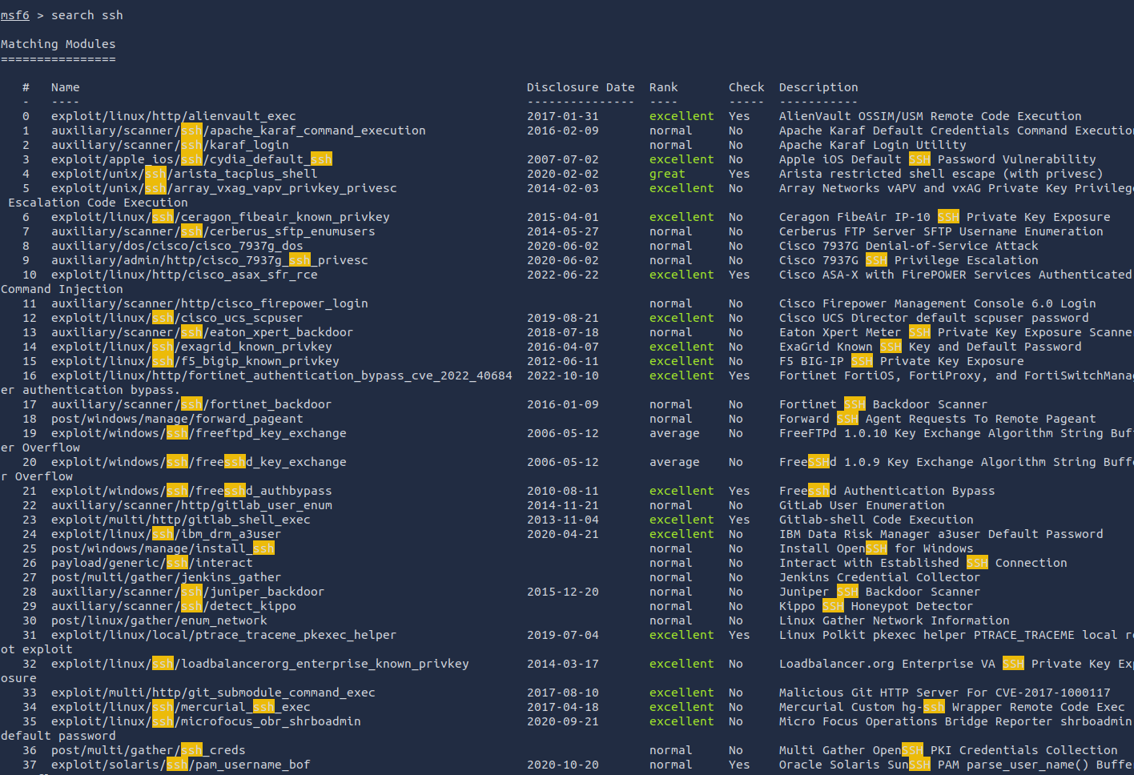

Select the aux scanner option for ssh_login to use to exploit and perform Brute Force



Use command ssh_login to equip the command



Once its equipped it will show



Type in options to see what the available settings for the scanner

We need to set some targets for the brute force to work

First, **RHOSTS** is the ip address of our target

Next, STOP_ON_SUCCESS will stop once the scan finds the valid credentials



Then, USER_FILE is the list of usernames



And PASS_FILE is the list of passwords



Finally, set the VERBOSE, which will display all of the attempts



Run the brute force

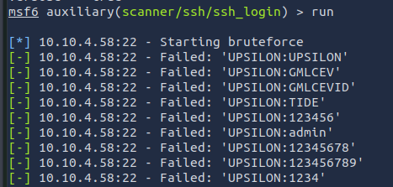

The scan will stop once it finds a success as shown below

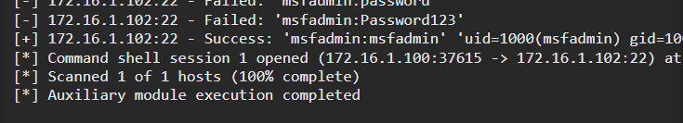

When the valid credentials were found we can see the current active session using the session command

To interact with the session, use the -I flag and then you will be connected to the target via SSH and can run commands like normal

